Mauritania ROUTE 8 days / 7 nights

ITINERARY:

Day 1; Country of origin – NOUAKCHOT
Reception at the airportTransfer to the hotel. Hotel de la Bienvenue or similar. A.D.

Day 2; NOUAKCHOT - ATAR
Breakfast at the hotel and chat with the guide to learn about the day's activities. Visit to the central market of Nouakchott (there is not much else to visit in this city founded in the 1940s) and route to the cultural center of the country. Stops en route. The landscape increasingly deserted and desolate. Few towns and some nomadic camps. Afternoon arrival to Atar, capital of the Adrar region, an area of oases, caravan cities and the area of greatest scenic and cultural interest in Mauritania. Etoile de Maure tented camp. A.D.

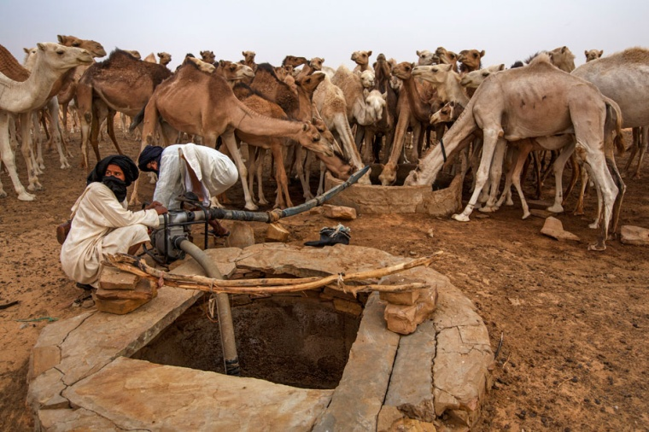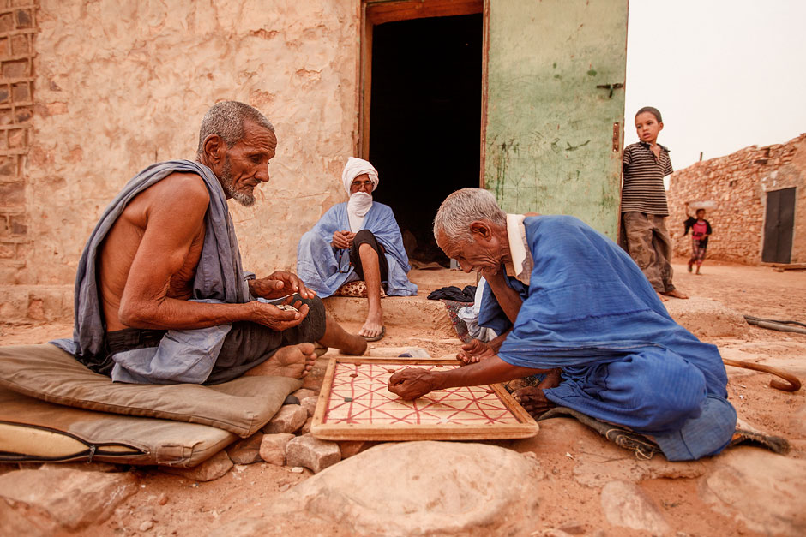
Day 3; ATAR - OUADANE
Breakfast and route through the desert to the historic city of Ouadane or Wadan. Stop en route to visit some of the rock carvings discovered in the area that indicate that this desert was an orchard full of fauna and vegetation centuries ago. It was founded in 1147 by the Idalwa el Hadji Berber tribe and quickly became an important meeting and transit point for caravans. The Portuguese established a commercial center in 1487, but the city began its decline in the 16th century. The old city is declared a World Heritage Site by UNESCO. Although in ruins, it is basically intact, while the new city grows outside the walls. We will walk through the old and new cities (also of great interest). The date palm groves survive around the city and are, along with camel farming and incipient tourism, the only source of income for this decadent city that refuses to disappear. Night in haima in the dunes near Ouadane. PC

Day 4; OUADANE - ADRAR DESERT
Breakfast. We will enter the Adrar desert, a changing landscape of dunes, bushes, stone plains... We will come across some nomads who survive in the desert with their dromedaries and herds of goats. After the visit. Night in a haima in the nearby dunes of Chingetti. PC

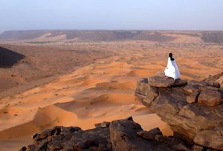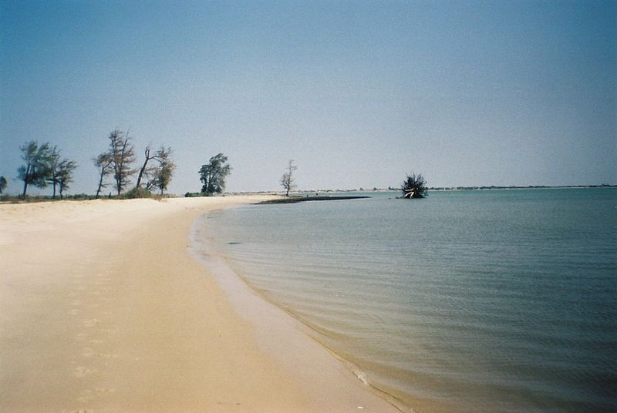

Day 5; ADRAR DESERT - CHINGUETTI
Breakfast. Through the desert route we will reach Chingetti. Chinguetti was founded at the end of the 13th century and was a caravan trade center between North Africa and Black Africa, being the metropolis with the greatest cultural apogee in the region at the beginning of the 17th century. About 12 libraries with more than 1,300 manuscripts of incalculable value are preserved from this period, some of them dating from the 9th and 10th centuries, with texts from the Koran, philosophy, grammar, medicine, mathematics, poetry, astronomy, etc. Currently Chinguetti is the 7th Holy City of Islam, UNESCO World Heritage since 1996, Cultural City of Mauritania and Gate to the Desert. This city has survived for 7 centuries, thanks to the energy and creativity of its inhabitants. From long periods of drought, epidemics, famine, etc. irreparable damage has occurred. Devoid of a large part of its population, it is currently in a delicate situation due to the incessant advance of the desert. According to information provided by the mayor of Chinguetti, the current population of the municipality is around 15,000 inhabitants, of which 5,000 live settled in the City of Chinguetti and the remaining 10,000 are nomads who move through the desert around Chinguetti. looking for water and pasture for the camels and cattle. Hotel Eden or similar. PM (lunch)
​
Day 5; ADRAR DESERT - CHINGUETTI
Breakfast. Through the desert route we will reach Chingetti. Chinguetti was founded at the end of the 13th century and was a caravan trade center between North Africa and Black Africa, being the metropolis with the greatest cultural apogee in the region at the beginning of the 17th century. About 12 libraries with more than 1,300 manuscripts of incalculable value are preserved from this period, some of them dating from the 9th and 10th centuries, with texts from the Koran, philosophy, grammar, medicine, mathematics, poetry, astronomy, etc. Currently Chinguetti is the 7th Holy City of Islam, UNESCO World Heritage since 1996, Cultural City of Mauritania and Gate to the Desert. This city has survived for 7 centuries, thanks to the energy and creativity of its inhabitants. From long periods of drought, epidemics, famine, etc. irreparable damage has occurred. Devoid of a large part of its population, it is currently in a delicate situation due to the incessant advance of the desert. According to information provided by the mayor of Chinguetti, the current population of the municipality is around 15,000 inhabitants, of which 5,000 live settled in the City of Chinguetti and the remaining 10,000 are nomads who move through the desert around Chinguetti. looking for water and pasture for the camels and cattle. Hotel Eden or similar. PM (lunch)

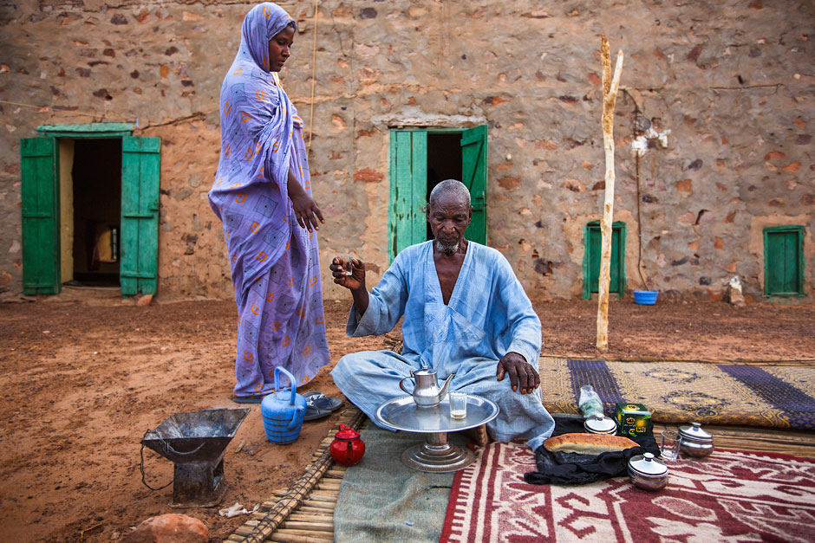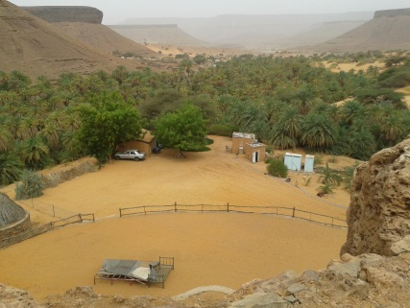

Day 6; CHINGETTI – TERGIT OASIS
Breakfast. After the last visits we will continue to the Tergit Oasis, a magical place located in a canyon of reddish rocks. The contrast between the green of the palm trees and the red of the rocks is extremely beautiful. Breakfast in the oasis. Walk through this natural space, domesticated by the Mauritanian nomads who have turned it into a transit point for their camel caravans since time immemorial. Haimas. PC

Day 7; TERGIT OASIS – NOUAKCHOT
Breakfast. After saying goodbye to our hosts, we head to Nouakchott. Stops en route. Depending on arrival time, rest or night tour of the capital's neighborhoods. Night at the hotel. Hotel Auberge de la Bienvenue or similar. A.D.

Day 8; NOUAKCHOT – Country of origin

Breakfast in this haven of peace. We will continue to Dakar to make the last purchases and visits. Dinner and day-use at the hotel. Transfer to the airport. Night flight. END OF OUR SERVICES

Prices include
Prices based on shared DBL room.
- Hotels and tents with breakfast.
- Spanish-speaking guide-coordinator throughout the trip.
- Detailed meals according to itinerary.
- Ground transportation in a private vehicle.
- Gasoline and tolls.
- The mentioned excursions.

